Shrinkage correlation: EURUSD and AUDUSD
Method 08 / eight-major panel / delta = 0.2 and Ledoit-Wolf / Alpari D1 full available history

Study setup
Logical pair: EURUSD , AUDUSD
Broker symbols: EURUSD_i , AUDUSD_i
Snapshot: 2026-11-03_majors_alpari_D1
Timeframe: D1
Common eight-major panel window: 1999-01-06 to 2026-11-02 (UTC bar dates)
Panel matched return count n: 7127
Dropped unfinished last bar dated 2026-11-03 UTC after a tick-volume check against the prior complete day.
Fixed shrinkage: delta=0.2, mu=3.9170889e-05 (mean of diag(S))
Ledoit-Wolf estimated delta: 0.0042157642
Panel symbols: EURUSD, GBPUSD, AUDUSD, NZDUSD, USDJPY, USDCHF, USDCAD, EURGBP
Complete matched rows (Excel): EURUSD-AUDUSD_Shrinkage_D1.xlsx
Complete matched rows (HTML table): EURUSD-AUDUSD_Shrinkage_D1_data.html

Method carried forward
Shrinkage blends the sample covariance matrix S of matched daily log returns of close, ln(close_t / close_t-1), toward a simple target, then converts the shrunk covariance into correlations. Quotes are not inverted. This experiment builds one common calendar across all eight majors, forms S with the unbiased n-1 divisor, then reports two shrinkage specs: fixed delta = 0.2 with mu equal to the average sample variance (mu * I target), and sklearn Ledoit-Wolf with its estimated delta. Pair reports pull rho_ij from those panel matrices. Same-panel Pearson r is a side check only. Shrinkage improves conditioning; it is not a cause, not a lead, and not a trading signal.

Results
pearson_r | rho_02 | rho_LW | rho_02_minus_r | rho_LW_minus_r | delta_LW
0.558036 | 0.453734 | 0.555859 | -0.104302 | -0.002177 | 0.00421576

Conclusion
Over the common 7127-day eight-major panel for EURUSD and AUDUSD (broker quote directions unchanged), fixed-delta shrinkage correlation at delta=0.2 is 0.4537 (positive, moderate linear link in this sample). Ledoit-Wolf rho is 0.5559 with estimated delta=0.004216. Same-panel Pearson r is 0.5580 (rho_02 minus r = -0.1043; rho_LW minus r = -0.0022). This does not establish cause, lead-lag, or a lasting trading rule.

Charts
Daily closes
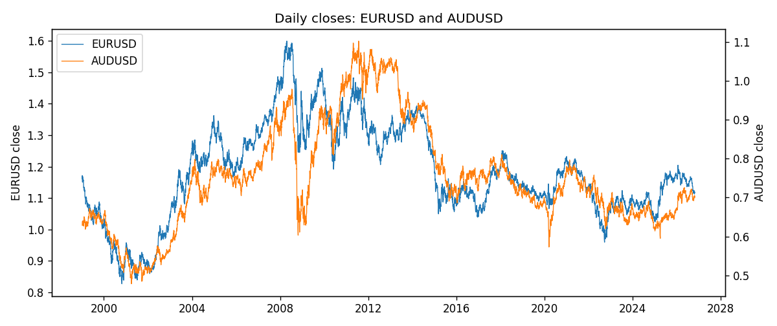
Daily log returns
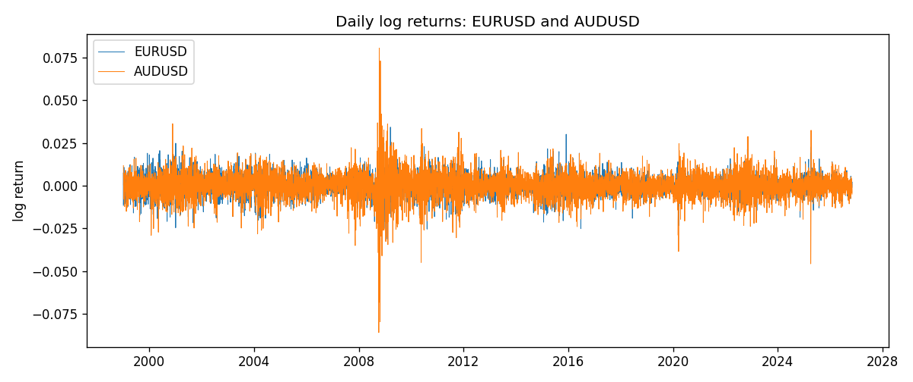
Log-return scatter
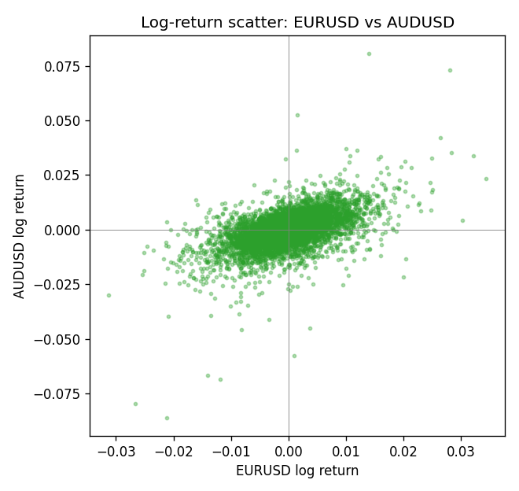

Data report
Every panel row for this pair slice is stored in the sibling Excel workbook named EURUSD-AUDUSD_Shrinkage_D1.xlsx. Full-panel covariance and correlation matrices are saved once under outputs/ as CSV files. Embedding all rows as a Word table is impractical at this length; the Word file holds the column list, column summaries, and the first and last 15 matched rows.
Columns: time, EURUSD_open, EURUSD_high, EURUSD_low, EURUSD_close, EURUSD_tick_volume, EURUSD_spread, EURUSD_real_volume, EURUSD_log_return, AUDUSD_open, AUDUSD_high, AUDUSD_low, AUDUSD_close, AUDUSD_tick_volume, AUDUSD_spread, AUDUSD_real_volume, AUDUSD_log_return
Column summaries (panel rows)
column | count | mean | std | min | 25% | 50% | 75% | max
EURUSD_open | 7127 | 1.1819407 | 0.15065555 | 0.8272 | 1.086455 | 1.16615 | 1.294285 | 1.5995
EURUSD_high | 7127 | 1.1870746 | 0.15125674 | 0.8326 | 1.09055 | 1.17128 | 1.29974 | 1.6038
EURUSD_low | 7127 | 1.1769341 | 0.14996546 | 0.8227 | 1.082375 | 1.16257 | 1.288915 | 1.5865
EURUSD_close | 7127 | 1.1819858 | 0.15061943 | 0.8267 | 1.08652 | 1.16617 | 1.294345 | 1.5997
EURUSD_tick_volume | 7127 | 103994.86 | 174033.72 | 469 | 9542.5 | 53148 | 99923.5 | 1471626
EURUSD_spread | 7127 | 19.176652 | 16.472988 | 0 | 8 | 12 | 20 | 50
EURUSD_real_volume | 7127 | 4.0656436e+10 | 1.6756658e+11 | 0 | 0 | 0 | 0 | 3.6149665e+12
EURUSD_log_return | 7127 | -3.8e-07 | 0.00580028 | -0.03123819 | -0.00324243 | 8.31e-06 | 0.00325629 | 0.03433183
AUDUSD_open | 7127 | 0.75283275 | 0.13531386 | 0.4785 | 0.66158 | 0.7319 | 0.812805 | 1.10284
AUDUSD_high | 7127 | 0.75689359 | 0.13587198 | 0.4878 | 0.66567 | 0.73555 | 0.8193 | 1.10795
AUDUSD_low | 7127 | 0.74877471 | 0.1346251 | 0.4775 | 0.65837 | 0.72811 | 0.80713 | 1.0975
AUDUSD_close | 7127 | 0.75288849 | 0.13529323 | 0.4786 | 0.661725 | 0.7321 | 0.812865 | 1.10169
AUDUSD_tick_volume | 7127 | 78106.737 | 138648.75 | 109 | 5647 | 44017 | 71744.5 | 1234623
AUDUSD_spread | 7127 | 30.658622 | 16.888951 | 0 | 13 | 30 | 50 | 50
AUDUSD_real_volume | 7127 | 5.2965195e+09 | 1.2602867e+11 | 0 | 0 | 0 | 0 | 3.811512e+12
AUDUSD_log_return | 7127 | 3.23e-05 | 0.0075548 | -0.08602525 | -0.00385041 | 0.00029027 | 0.00415332 | 0.0806166
First 15 panel rows (selected columns)
time | EURUSD_close | AUDUSD_close | EURUSD_log_return | AUDUSD_log_return
1999-01-06 | 1.1623 | 0.6289 | -0.011547966 | 0.011836351
1999-01-07 | 1.1712 | 0.6345 | 0.0076280636 | 0.0088650256
1999-01-08 | 1.1585 | 0.6347 | -0.010902799 | 0.00031515916
1999-01-11 | 1.1503 | 0.6393 | -0.007103287 | 0.0072213815
1999-01-12 | 1.1555 | 0.6362 | 0.0045103728 | -0.0048608485
1999-01-13 | 1.1681 | 0.6312 | 0.010845346 | -0.0078902098
1999-01-14 | 1.1681 | 0.6295 | 0 | -0.002696916
1999-01-15 | 1.1563 | 0.634 | -0.010153245 | 0.007123101
1999-01-18 | 1.1605 | 0.6346 | 0.0036256946 | 0.00094592471
1999-01-19 | 1.1603 | 0.6392 | -0.00017235436 | 0.0072225153
1999-01-20 | 1.1566 | 0.64 | -0.0031939256 | 0.0012507819
1999-01-21 | 1.1601 | 0.6405 | 0.0030215416 | 0.00078094498
1999-01-22 | 1.1587 | 0.6327 | -0.0012075213 | -0.012252745
1999-01-25 | 1.1552 | 0.6302 | -0.0030251979 | -0.0039591468
1999-01-26 | 1.1562 | 0.6305 | 0.00086527651 | 0.00047592608
Last 15 panel rows (selected columns)
time | EURUSD_close | AUDUSD_close | EURUSD_log_return | AUDUSD_log_return
2026-10-13 | 1.11965 | 0.69821 | 0.0037402957 | 0.0035007712
2026-10-14 | 1.11545 | 0.69715 | -0.0037582255 | -0.0015193215
2026-10-15 | 1.12172 | 0.69191 | 0.0056053107 | -0.0075447063
2026-10-16 | 1.12371 | 0.69426 | 0.0017724895 | 0.0033906408
2026-10-19 | 1.12086 | 0.6978 | -0.0025394633 | 0.0050859986
2026-10-20 | 1.12354 | 0.70022 | 0.0023881672 | 0.0034620426
2026-10-21 | 1.12318 | 0.70275 | -0.00032046717 | 0.0036066384
2026-10-22 | 1.12139 | 0.70186 | -0.0015949606 | -0.0012672558
2026-10-23 | 1.11989 | 0.70353 | -0.001338521 | 0.0023765656
2026-10-26 | 1.11735 | 0.70128 | -0.0022706559 | -0.0032032829
2026-10-27 | 1.11272 | 0.70245 | -0.004152342 | 0.0016669876
2026-10-28 | 1.1152 | 0.70533 | 0.0022262927 | 0.0040915541
2026-10-29 | 1.11772 | 0.70245 | 0.0022571351 | -0.0040915541
2026-10-30 | 1.11644 | 0.70316 | -0.0011458446 | 0.0010102376
2026-11-02 | 1.11881 | 0.69971 | 0.002120569 | -0.0049184984

